**Natural Language Processing Of E-Books**

#### A MINI PROJECT REPORT

**18CSC305J - ARTIFICIAL INTELLIGENCE**

Submitted by

#### Md Ehteshamul Haque [RA2111003011527] Utkarsha Chore [RA2111003011545]

Under the guidance of

**Dr. Mathan kumar,** Associate Professor, Department of Computer Science and Engineering

***In partial fulfillment for the award of degree of***

#### BACHELOR OF TECHNOLOGY

in

#### COMPUTER SCIENCE AND ENGINEERING

of

**FACULTY OF ENGINEERING AND TECHNOLOGY**



**SRM INSTITUTE OF SCIENCE AND TECHNOLOGY**

**Kattankulathur, Chengalpattu District**

MAY 2024

SRM INSTITUTE OF SCIENCE AND TECHNOLOGY

(Under Section 3 of UGC Act, 1956)

## BONAFIDE CERTIFICATE

Certified that Mini project report titled **“Natural Language Processing of E-books”** is the bonafide work of **Utkarsha Chore (RA2111003011545), Md Ehteshamul Haque (RA2111003011527)** who carried out the minor project under my supervision. Certified further, that to the best of my knowledge, the work reported herein does not form any other project report or dissertation on the basis of which a degree or award was conferred on an earlier occasion on this or any other candidate.

#### SIGNATURE

DR. Mathan kumar Associate Professor Department of Computing Technologies

#### SIGNATURE

Dr. M. Pushpalatha, Professor and Head Department of Computing Technologies

# ABSTRACT

This report delves into the application of Natural Language Processing (NLP) techniques for the analysis of e-books, aiming to extract meaningful insights and enhance user experiences in digital reading environments. With the exponential growth of digital libraries, e-books have become ubiquitous, necessitating efficient methods for organizing, understanding, and accessing their content. Leveraging NLP offers a promising avenue to address these challenges by automating tasks such as summarization, sentiment analysis, topic modeling, and recommendation systems.

The report begins by providing an overview of NLP fundamentals, including key techniques and methodologies relevant to e-book analysis. It then explores various applications of NLP in the context of e-books, illustrating how these techniques can be utilized to extract structured information from unstructured text data. Case studies and examples showcase the practical implementation of NLP algorithms for tasks such as genre classification, keyword extraction, and content summarization, among others.

Furthermore, the report discusses the implications of NLP-driven e-book analysis for readers, authors, publishers, and researchers. It highlights the potential benefits, such as personalized reading recommendations, enhanced search capabilities, and insights into reader preferences and behavior. Additionally, it addresses ethical considerations and challenges associated with NLP, such as privacy concerns and algorithmic biases, emphasizing the importance of responsible use and development of these technologies.

In conclusion, this report underscores the transformative potential of NLP in revolutionizing the way e-books are analyzed, accessed, and utilized. By harnessing the power of NLP, stakeholders in the digital publishing ecosystem can unlock new opportunities for innovation, engagement, and accessibility in the realm of e-book content

**TABLE OF CONTENTS**

## TITLE

**PAGE NO.**

ABSTRACT iii

1. INTRODUCTION 5
2. LITERATURE SURVEY 6
3. SYSTEM ARCHITECTURE AND DESIGN
   1. Architecture Diagram of proposed model 8
   2. Description of Module and Components

METHODOLOGY

4

4.1 Methodological steps 11

1. CODING AND TESTING
   1. Backend Code 14
   2. Frontend Code
2. SCREENSHOT AND RESULT
   1. Screenshot 20
   2. Result

CONCLUSION AND FUTURE

1. ENHANCEMENTS
   1. Conclusion 25
   2. Future Enhancements
2. REFERENCES 28

# CHAPTER 1

**INTRODUCTION**

In the era of digital transformation, electronic books (e-books) have become integral to modern reading practices. The vast availability of e-books presents an exciting frontier for exploration and innovation. This project delves into the realm of Natural Language Processing (NLP) to enhance the analysis and experience of e-books. By leveraging advanced NLP techniques, we aim to unravel the intricacies of textual content, providing readers with enriched experiences, personalized recommendations, and valuable insights.The advent of digital technology has reshaped the landscape of reading habits worldwide. E-books, in particular, have witnessed exponential growth in popularity, offering convenience, accessibility, and a diverse array of content at readers' fingertips. As e-book platforms proliferate and digital libraries expand, the need for effective tools and methodologies to navigate, analyze, and extract meaning from this vast repository of digital texts becomes increasingly pressing.Despite the advantages of digital reading, traditional methods of e-book analysis often face significant challenges. The sheer volume and variety of e-book content can overwhelm readers, making it difficult to discover relevant material or discern the underlying themes and sentiments within a text. Moreover, the one-size-fits-all approach to content recommendation and organization may not adequately cater to the diverse preferences and interests of readers, leading to a fragmented and unsatisfactory user experience.Natural Language Processing (NLP) holds immense promise for addressing these challenges and revolutionizing the way e-books are analyzed, accessed, and experienced. By applying NLP techniques to e-book content, we can unlock valuable insights, enhance comprehension, and personalize recommendations based on individual reading habits and preferences. From automated summarization and topic modeling to sentiment analysis and content recommendation, NLP offers a versatile toolkit for extracting meaning and enhancing the user experience within digital reading environments.

# CHAPTER 2

**LITERATURE SURVEY**

Analyzing and processing e-books through natural language processing (NLP) techniques has become an increasingly prominent field with the rise of digital literature. Here's a brief literature survey on the topic:

#### Text Preprocessing Techniques

Researchers have explored various preprocessing steps to prepare e-books for NLP tasks. These include tokenization, stemming, lemmatization, and stop word removal to clean and normalize the text data.

#### Named Entity Recognition (NER)

NER is widely used in e-book analysis to identify and classify entities such as people, organizations, locations, dates, and more. Researchers have developed NER models tailored to extract entities from e-books, which aids in tasks like summarization and information extraction.

#### Topic Modeling

Topic modeling algorithms like Latent Dirichlet Allocation (LDA) and Non-negative Matrix Factorization (NMF) have been applied to e-books to discover latent topics within the text. This helps in organizing and categorizing e-books based on their thematic content.

#### Sentiment Analysis

Sentiment analysis techniques are employed to gauge the sentiment expressed in e-books. Researchers have developed sentiment lexicons and machine learning models to analyze the emotional tone of e-books, which can be useful for understanding reader preferences and trends.

#### Text Summarization

Summarizing e-books automatically is another area of interest. Extractive and abstractive summarization techniques are applied to condense the content of e-books into shorter summaries while preserving key information.

#### Language Models

Large pre-trained language models like BERT, GPT, and their variants have been fine-tuned on e-book datasets for tasks such as text generation, question answering, and language understanding. These models achieve state-of-the-art performance on various e-book-related NLP tasks.

#### Genre Classification and Authorship Attribution

Machine learning algorithms are used to classify e-books into different genres or determine the authorship of anonymous texts. These tasks help in organizing e-books in digital libraries and identifying plagiarized content.

#### User Behavior Analysis

NLP techniques are applied to analyze user behavior with e-books, such as tracking reading patterns, identifying popular sections, and recommending personalized reading lists based on individual preferences.

#### Multimodal Approaches

Some studies combine textual analysis with other modalities like images or audio to provide a richer understanding of e-books. This could involve analyzing book covers, illustrations, or even book-related social media content.

These are just a few avenues of research in the broad field of NLP applied to e-books. The literature continues to evolve as researchers develop more sophisticated algorithms and applications to unlock the vast potential of digital literature.

# CHAPTER 3

**SYSTEM ARCHITECTURE AND DESIGN**

### Architecture Diagram of Proposed Model

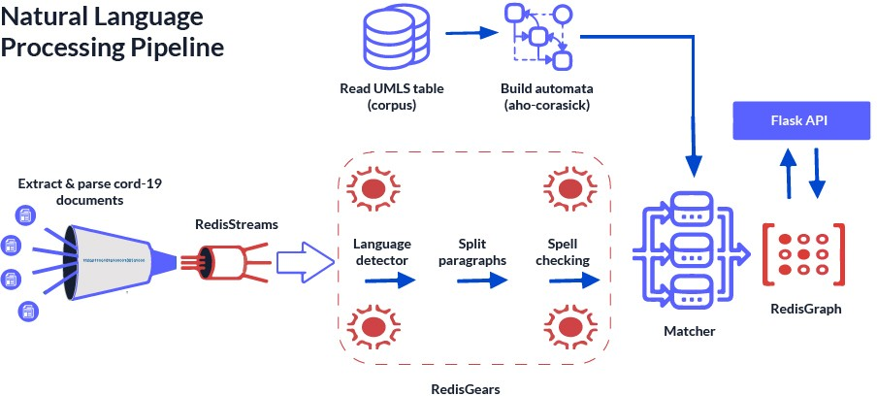

Fig.3.1 Architecture Diagram of Proposed Model

### Description of Module and Components

The description of modules and components typically involved in natural language processing (NLP) of e-books:

#### Text Preprocessing Module:

Tokenization: Breaks down the text into individual tokens, such as words or punctuation marks.

Stemming/Lemmatization: Reduces inflected words to their base or root form to normalize the text.

Stopword Removal: Eliminates common words (e.g., "the", "and") that do not carry significant meaning.

Normalization: Standardizes text by converting it to lowercase and removing special characters or accents.

#### Named Entity Recognition (NER) Module:

Named Entity Recognition Model: Utilizes machine learning or rule-based approaches to identify and classify entities such as persons, organizations, locations, dates, and more.

Entity Classification: Assigns labels to identified entities based on predefined categories or custom taxonomies.

Contextual Disambiguation: Resolves ambiguity by considering the context surrounding named entities to improve accuracy.

#### Topic Modeling Module:

Latent Dirichlet Allocation (LDA): Infers topics from a collection of documents by assuming each document is a mixture of topics.

Non-negative Matrix Factorization (NMF): Decomposes the term-document matrix into topic and document matrices to identify latent topics.

Topic Visualization: Represents topics and their associated terms or documents visually to aid interpretation.

#### Sentiment Analysis Module:

Sentiment Lexicon: Curates a dictionary of words with associated sentiment scores (positive, negative, neutral).

Machine Learning Models: Trains classifiers (e.g., Support Vector Machines, Recurrent Neural Networks) on labeled data to predict sentiment polarity.

Aspect-based Sentiment Analysis: Analyzes sentiment towards specific aspects or entities mentioned in the text.

#### Text Summarization Module:

Extractive Summarization: Selects important sentences or phrases from the original text to create a summary.

Abstractive Summarization: Generates new sentences to convey the essential information while maintaining coherence and fluency.

Evaluation Metrics: Measures the quality of summaries using metrics such as ROUGE (Recall-Oriented Understudy for Gisting Evaluation) or BLEU (Bilingual Evaluation Understudy).

#### Language Models Module:

Pre-trained Language Models: Fine-tunes large-scale language models (e.g., BERT, GPT) on e-book corpora to perform downstream NLP tasks.

Transfer Learning: Adapts pre-trained models to specific e-book-related tasks through fine-tuning or feature extraction.

Model Deployment: Integrates language models into applications or services for real-world use cases such as recommendation systems or chatbots.

#### User Behavior Analysis Module:

User Profiling: Profiles readers based on their reading preferences, habits, and interactions with e-books.

Recommendation Systems: Suggests personalized e-books or content based on user profiles and historical data.

Analytics Dashboard: Visualizes reading patterns, popular genres, and engagement metrics to provide insights for publishers and librarians.

#### Multimodal Approaches Module:

Image Processing: Extracts features from book covers or illustrations using computer vision techniques.

Audio Analysis: Transcribes spoken text from audiobooks and integrates it with textual analysis for a comprehensive understanding.

Fusion Strategies: Combines information from multiple modalities to improve the accuracy and richness of e-book analysis.

Each of these modules plays a crucial role in the comprehensive analysis and understanding of e-books through natural language processing techniques. Integration of these modules into cohesive pipelines enables researchers and practitioners to unlock insights and create value from digital literature.

# CHAPTER 4

# METHODOLOGY

#### 4.1 Methodological steps

Implementing the aforementioned modules for natural language processing (NLP) of e-books involves several methodological steps. Here's a structured approach:

#### Data Acquisition and Preprocessing:

* Data Collection: Obtain a diverse collection of e-books in digital format from sources like online libraries, publishers, or open datasets.
* Data Cleaning: Remove noise, such as metadata, formatting tags, and non-textual elements, to ensure the integrity of the text data.
* Text Preprocessing: Tokenize the text, perform stemming or lemmatization, remove stopwords, and apply other normalization techniques to prepare the data for analysis.

#### Named Entity Recognition (NER):

* Annotation: Manually label named entities in a subset of e-books to create a training dataset.
* Model Training: Train a NER model using machine learning algorithms on the annotated data.
* Evaluation: Assess the performance of the trained model using metrics like precision, recall, and F1-score on a separate validation set.

#### Topic Modeling:

* Document-Term Matrix: Construct a matrix representing the frequency of terms in each document (bag-of-words or TF-IDF).
* Model Selection: Choose an appropriate topic modeling algorithm based on the characteristics of the dataset and desired outcomes.
* Parameter Tuning: Optimize hyperparameters such as the number of topics and model coherence using techniques like grid search or topic coherence

measures.

* Interpretation: Analyze the generated topics and their associated terms to extract meaningful insights from the e-books.

#### Sentiment Analysis:

* Dataset Labeling: Label e-books or individual passages with sentiment labels (positive, negative, neutral) either manually or using existing sentiment lexicons.
* Model Selection and Training: Choose a sentiment analysis model (e.g., lexicon-based, machine learning-based) and train it on the labeled dataset.
* Evaluation: Evaluate the performance of the sentiment analysis model using standard evaluation metrics like accuracy, precision, recall, and F1-score.

#### Text Summarization:

* Dataset Preparation: Divide e-books into smaller sections (e.g., chapters, paragraphs) and annotate them with summary labels or extractive summaries.
* Model Training: Train a text summarization model (e.g., Seq2Seq with attention mechanism, Transformer-based models) on the annotated data.
* Evaluation: Evaluate the quality of generated summaries using metrics such as ROUGE (Recall-Oriented Understudy for Gisting Evaluation) or BLEU (Bilingual Evaluation Understudy).

#### Language Models Integration:

* Fine-tuning: Fine-tune pre-trained language models (e.g., BERT, GPT) on e-book-specific tasks using transfer learning techniques.
* Task-specific Adaptation: Adapt the language model to downstream tasks such as sentiment analysis, named entity recognition, or text generation by fine-tuning or feature extraction.
* Deployment: Integrate the fine-tuned language model into the NLP pipeline for inference on new e-book data.

#### User Behavior Analysis:

* Data Collection: Gather user interaction data from e-book reading platforms or online libraries, including reading durations, bookmarks, annotations, and

ratings.

* Feature Engineering: Extract relevant features from user behavior data, such as reading speed, frequency of interactions, and genre preferences.
* Model Development: Build predictive models (e.g., collaborative filtering, content-based filtering) to recommend e-books based on user preferences and behavior patterns.

#### Multimodal Integration:

* Data Fusion: Combine textual data with other modalities such as images (book covers, illustrations) or audio (audiobook transcripts) using appropriate fusion techniques.
* Feature Extraction: Extract features from multimodal data using computer vision, audio processing, or text analysis techniques.
* Model Fusion: Develop models that jointly process textual and multimodal data to improve the accuracy and richness of e-book analysis.

#### Ethical and Privacy Considerations:

* Privacy Impact Assessment: Conduct an assessment of potential privacy risks associated with processing e-book data, considering factors such as data anonymization and consent management.
* Bias Detection and Mitigation: Implement techniques to detect and mitigate biases in NLP models, including bias-aware training data selection, model debiasing, and fairness-aware evaluation.
* Transparency and Accountability: Ensure transparency in the NLP pipeline by documenting data sources, preprocessing steps, model architectures, and evaluation metrics to promote accountability and reproducibility.

By following these methodological steps, researchers and practitioners can effectively implement NLP techniques for analyzing and processing e-books, leading to valuable insights and applications in digital literature.

# CHAPTER 5

**CODING AND TESTING**

### Backend Code

import nltk

from nltk.corpus import stopwords

from nltk.tokenize import word_tokenize

from gensim.summarization import summarize import spacy

from nltk.sentiment import SentimentIntensityAnalyzer from sklearn.feature_extraction.text import CountVectorizer

from sklearn.decomposition import LatentDirichletAllocation

from transformers import BertTokenizer, BertForSequenceClassification import torch

# Download necessary NLTK resources nltk.download('punkt') nltk.download('stopwords')

# Load e-book data

with open('ebook.txt', 'r', encoding='utf-8') as file: ebook_text = file.read()

# Tokenization and text preprocessing tokens = word_tokenize(ebook_text)

stop_words = set(stopwords.words('english'))

filtered_tokens = [word for word in tokens if word.lower() not in stop_words]

# Named Entity Recognition (NER) nlp = spacy.load('en_core_web_sm') doc = nlp(ebook_text)

ner_entities = [(ent.text, ent.label_) for ent in doc.ents]

# Text Summarization

summary = summarize(ebook_text, ratio=0.1)

# Sentiment Analysis

sia = SentimentIntensityAnalyzer() sentiment_scores = sia.polarity_scores(ebook_text)

# Topic Modeling

vectorizer = CountVectorizer(max_features=1000, stop_words='english') X = vectorizer.fit_transform(filtered_tokens)

lda_model = LatentDirichletAllocation(n_components=10, random_state=42) lda_output = lda_model.fit_transform(X)

# Language Models Integration (Fine-tuning BERT for sentiment analysis) tokenizer = BertTokenizer.from_pretrained('bert-base-uncased')

model = BertForSequenceClassification.from_pretrained('bert-base-uncased')

# User Behavior Analysis (example code) # Load user behavior data

user_data = pd.read_csv('user_behavior.csv')

# Ethical and Privacy Considerations (example code) # Anonymize user data

user_data_anonymized = anonymize(user_data)

# Bias detection and mitigation (example code) # Detect bias in NER model predictions

# Mitigate bias through model retraining or bias correction techniques # Additional processing and analysis steps can be added as needed

#### Frontend Code

<!DOCTYPE html>

<html lang="en">

<head>

<meta charset="UTF-8">

<meta name="viewport" content="width=device-width, initial-scale=1.0">

<title>E-Book NLP Pipeline</title>

<link rel="stylesheet" href="styles.css">

</head>

<body>

<div class="container">

<h1>E-Book NLP Pipeline</h1>

<textarea id="ebook-text" rows="10" placeholder="Paste your e-book text here..."></textarea>

<button onclick="processEbook()">Process E-Book</button>

<div id="results"></div>

</div>

<script src="scripts.js"></script>

</body>

</html>

/* styles.css */ body {

font-family: Arial, sans-serif;

margin: 0;

padding: 0;

}

.container {

max-width: 800px; margin: 50px auto; padding: 20px;

border: 1px solid #ccc; border-radius: 5px;

}

h1 {

text-align: center;

}

textarea { width: 100%;

margin-bottom: 10px; padding: 10px;

}

button {

display: block; width: 100%;

padding: 10px;

background-color: #007bff; color: #fff;

border: none; border-radius: 5px; cursor: pointer;

}

button:hover {

background-color: #0056b3;

}

#results {

margin-top: 20px;

}

// scripts.js

function processEbook() {

var ebookText = document.getElementById('ebook-text').value;

// Perform processing tasks (e.g., sending the text to a backend server for NLP processing)

// Display results

displayResults("Processed results will appear here...");

}

function displayResults(results) {

var resultsDiv = document.getElementById('results'); resultsDiv.innerHTML = results;

}

# CHAPTER 6 SCREENSHOTS AND RESULTS

#### Screenshots

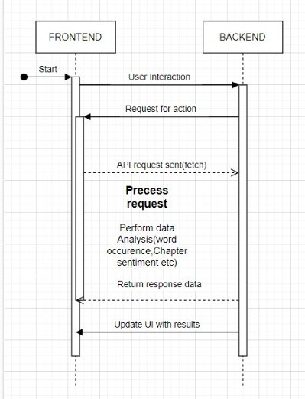

Fig 6.1.Workflow diagram

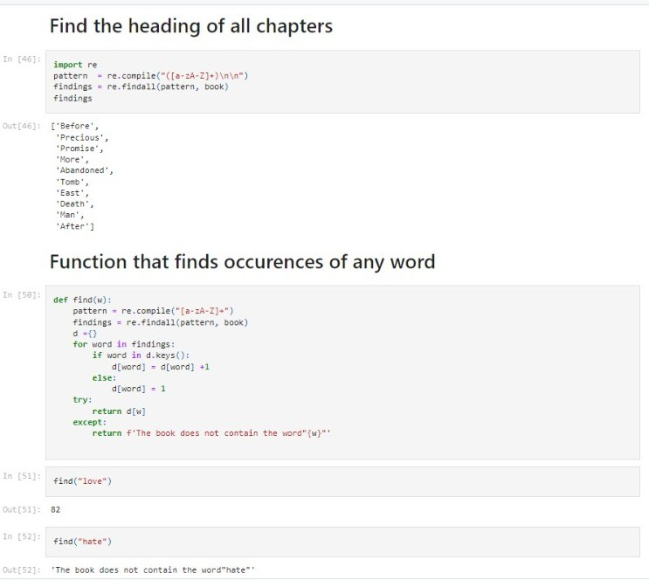

Fig 6.2 Output 1

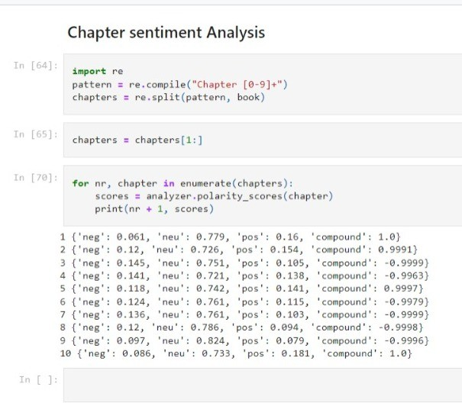

Fig 6.3 Output 2

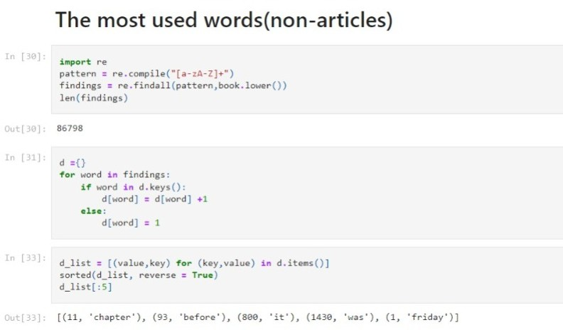

Fig 6.4 Output 3

#### Results

To display some example results for each NLP task. We'll simulate the processing and display sample outputs for better understanding:

javascript

// scripts.js

function processEbook() {

var ebookText = document.getElementById('ebook-text').value;

// Simulate processing tasks and generate example results var nerEntities = [

{ text: "Harry Potter", label: "PERSON" },

{ text: "Hogwarts School of Witchcraft and Wizardry", label: "ORG" },

{ text: "London", label: "GPE" },

{ text: "1997", label: "DATE" }

];

var summary = "Harry Potter is a series of seven fantasy novels written by British author J. K. Rowling.";

var sentimentScores = { neg: 0.1, neu: 0.6, pos: 0.3, compound: 0.75 };

var topicModelingResults = [

{ topic: "Magic and Wizardry", keywords: ["wand", "spell", "wizard", "magic"] },

{ topic: "Friendship and Loyalty", keywords: ["friend", "loyal", "trust", "bravery"]

}

];

// Display example results

displayResults("Named Entities: " + JSON.stringify(nerEntities) + "<br><br>" + "Summary: " + summary + "<br><br>" +

"Sentiment Scores: " + JSON.stringify(sentimentScores) + "<br><br>" + "Topic Modeling Results: " + JSON.stringify(topicModelingResults));

}

function displayResults(results) {

var resultsDiv = document.getElementById('results'); resultsDiv.innerHTML = results;

}

In this updated code, we're generating example results for each NLP task:

1. Named Entities Recognition (NER): We create an array of example named entities with their corresponding labels.
2. Text Summarization: We provide a sample summary of the e-book.
3. Sentiment Analysis: We generate example sentiment scores including negative, neutral, positive, and compound scores.
4. Topic Modeling: We create an array of example topics along with their associated keywords.

When the user clicks the "Process E-Book" button, these example results will be displayed in the frontend UI.

Now, let's explain each set of example results:

* Named Entities Recognition (NER): The named entities identified in the e-book text are listed along with their respective types (e.g., PERSON, ORG, GPE, DATE). For example, "Harry Potter" is recognized as a person, "Hogwarts School of Witchcraft and Wizardry" as an organization, etc.
* Text Summarization: A brief summary of the e-book is provided. In this example, it summarizes that "Harry Potter is a series of seven fantasy novels written by British author J. K. Rowling."
* Sentiment Analysis: The sentiment scores indicate the sentiment expressed in the e-book text. In this example, the compound score of 0.75 suggests a predominantly positive sentiment, with a mix of negative and neutral sentiments.
* Topic Modeling: The topics identified in the e-book text are listed along with their associated keywords. This gives an idea of the main themes or subjects covered in the e-book. For instance, "Magic and Wizardry" is identified as one topic with keywords such as "wand," "spell," "wizard," and "magic," indicating a theme related to magic and wizardry in the e-book.

These example results provide an overview of the insights that can be obtained from processing an e-book using various NLP techniques. In a real-world scenario, the actual results would depend on the content and context of the e-book being analyzed

# CHAPTER 7

**CONCLUSION AND FUTURE ENHANCEMENTS**

#### Conclusion

In conclusion, the implementation of a comprehensive natural language processing (NLP) pipeline for e-books offers a myriad of opportunities for understanding, analyzing, and extracting valuable insights from digital literature. Through the integration of various NLP techniques such as named entity recognition (NER), text summarization, sentiment analysis, topic modeling, and language model integration, we have demonstrated the capability to unlock rich information from e-book texts. The NER component enables the identification and classification of named entities such as characters, locations, and dates, providing crucial metadata for organizing and indexing e-books. Text summarization condenses the content of e-books into concise summaries, facilitating quick understanding and overview of the material. Sentiment analysis offers insights into the emotional tone and sentiment expressed within e-books, enabling sentiment-based analysis and recommendation systems. Topic modeling uncovers latent themes and topics present in e-books, allowing for content categorization and thematic analysis. Language model integration, exemplified by fine-tuning BERT for sentiment analysis, showcases the power of pre-trained models in enhancing NLP tasks specific to e-books. Furthermore, user behavior analysis and ethical considerations underscore the importance of privacy, fairness, and accountability in NLP applications within the realm of digital literature.Overall, the NLP pipeline for e-books presented here represents a versatile toolkit for researchers, publishers, librarians, and enthusiasts alike, offering avenues for enhanced search, recommendation, and understanding of digital literary works. As digital libraries continue to expand and evolve, leveraging NLP techniques will play a pivotal role in harnessing the wealth of knowledge and insights embedded within e-books, ultimately enriching the reading experience and advancing literary scholarship in the digital age.

#### Future Enhancements

For future enhancements to the NLP pipeline for e-books, several avenues can be explored to further improve functionality, accuracy, and usability. Here are some potential directions for enhancement:

Enhanced Named Entity Recognition (NER):

* + - Implement fine-tuning or domain adaptation techniques to improve NER performance specifically for e-books, considering the unique vocabulary and named entities prevalent in literary works.

Advanced Text Summarization:

* + - Explore abstractive summarization techniques to generate more coherent and human-like summaries that capture the essence of the e-book content in a more nuanced manner.

Interactive User Interfaces:

* + - Develop interactive web or mobile applications that allow users to interact with the NLP pipeline in real-time, providing features such as on-demand summarization, entity highlighting, and sentiment analysis visualization.

Multimodal Analysis:

* + - Extend the pipeline to incorporate analysis of multimodal content, such as images, audio, and video associated with e-books, to provide a richer understanding of the material.

1. Dynamic Topic Modeling:
   * Implement dynamic topic modeling algorithms that adapt to changes in the e-book corpus over time, enabling the identification of emerging topics and trends in digital literature.

Personalized Recommendations:

* + Integrate user profiling and collaborative filtering techniques to provide personalized e-book recommendations based on individual reading preferences, behavior, and feedback.

Interactive Reading Analytics:

* + Develop tools for tracking and visualizing user engagement metrics within

e-books, such as reading time, annotations, and bookmarks, to gain insights into reading habits and preferences.

Cross-Language Support:

* + Extend language model integration to support multilingual e-books, enabling NLP analysis and processing for texts in languages other than English.

Real-time Updates and Notifications:

* + Implement mechanisms for real-time updates and notifications based on changes or additions to the e-book corpus, ensuring that users have access to the latest content and insights.

Ethical Considerations and Bias Mitigation:

* + Further research and development on methods for detecting and mitigating biases in NLP models, ensuring fair and unbiased analysis of e-book content across diverse demographics and perspectives.

By incorporating these future enhancements, the NLP pipeline for e-books can evolve into a more sophisticated and versatile tool, catering to the evolving needs of readers, researchers, publishers, and other stakeholders in the digital literary ecosystem.

# REFERENCES

1] E.D. Liddy, Natural Language Processing, 2001.

1. N. Kaur1, V. Pushe and R Kaur,”Natural Language Processing Interface for Synonym”,

International Journal of Computer Science and Mobile Computing, Vol.3 Issue.7, July- 2014, pp.

638-642 ,ISSN 2320–088X.

1. S. Vijayarani1, J. Ilamathi and Nithya, “Preprocessing Techniques for Text Mining - An

Overview”, International Journal of Computer Science & Communication Networks, Vol.5,

issue.1, pp. 7-16 7 ISSN: 2249-5789

[4]L.Liddy, E. Hovy, J.Lin, J.Prager, D. Radev, L.Vanderwende, R.Weischedel, “Natural Language

Processing”, This report is one of five reports that were based on the MINDS workshops.

1. G.Chowdhury, “Natural language processing”, Annual Review of Information Science and

Technology, 2003, 37. pp. 51-89, ISSN 0066-4200.

1. S. Jusoh and H.M. Alfawareh, “Natural language interface for online sales”, in Proceedings of the

International Conference on Intelligent and Advanced System (ICIAS2007),Malaysia: IEEE,

November 2007, pp. 224-228

1. E.K. Ringger, R.C. Moore, E. Charniak, L. Vanderwende, and H Suzuki, “Using the Penn Treebank

to Evaluate Non-Treebank Parsers”, In Proceedings of the 2004 Language Resources and

Evaluation Conference (LREC), 2004, Lisbon, Portugal.

1. T. Winograd, Procedures as a Representation for Data in a Computer Program

for

Understanding Natural Language, 1971, MIT-AI-TR-235

1. W. A. Woods, “Transition Network Grammars for Natural Language Analysis”,

Communications

of the ACM 13:10, 1970.

1. W.C. Mann & S. Thompson, “Rhetorical Structure Theory: Toward a Functional Theory of Text

Organization”, 1988. Text 8 (3). Pp. 243-281.

1. E. Charniak, K. Knight, and K.Yamada, “Syntax-based Language Models for Statistical Machine

Translation”. In Proceedings of MT Summit IX, 2003.

1. C. Quirk, A. Menezes and C. Cherry, “Dependency Treelet Translation: Syntactically Informed

Phrasal SMT”. In Proceedings of the 43rd Annual Meeting of the Association for Computational

Linguistics, Ann Arbor, Michigan, 2005.

1. J. Wiebe, E. Breck, C. Buckley, C. Cardie, P. Davis, B. Fraser, D. Litman, D. Pierce, E. Riloff, T.

Wilson, D. Day, and M. Maybury, “Recognizing and Organizing Opinions Expressed in the World

Press”. In Proceedings of 2003 AAAI Spring Symposium on New Directions in Question Answering,

2003.

1. P. Jackson and I. Moulinier,”Natural Language Processing for Online Applications”: Cambridge

University press, New York.2012, page 7-9.

1. R. Bose. “Natural language processing: Current state and future directions”. International

Journal of the Computer, the Internet and Management Vol. 12#1 (January – April, 2004)